You are given a two-dimensional 3\*3 array starting from A [0][0]. You should add the alternate elements of the array

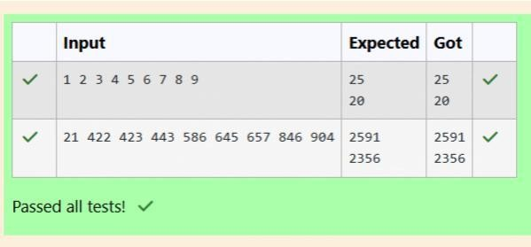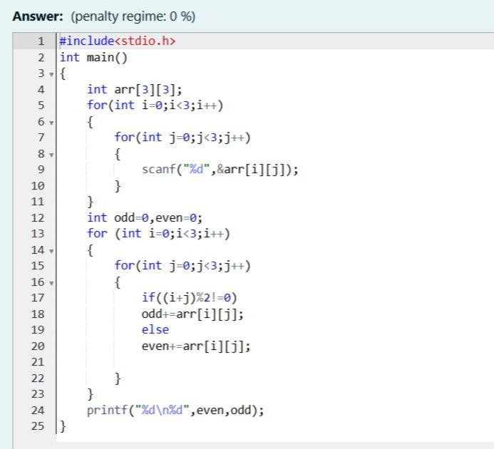

And print its sum. It should print two different numbers the first being sum of A 0 0, A 0 2, A 1 1, A 2 0, A 2 2 and A 0 1,

A 1 0, A 1 2, A 2 1.

Input Format

First and only line contains the value of array separated by single space Output format

First line should print sum of A 0 0, A 0 2, A 1 1, A 2 0, A 2 2

Second line should print sum of A 0 1, A 1 0, A 1 2, A 2 1



Shyam Lal, a wealthy landlord from the state of Rajasthan, being an old fellow and tired of doing hard work, decided to

Sell all his farmland and to live rest of his life with that money. No other farmer is rich enough to buy all his land so heDecided to partition the land into rectangular plots of

different sizes with different cost per unit area. So, he sold thesePlots to the farmers but made a mistake. Being illiterate, he made partitions that could be overlapping. When the Farmers came to know about it, they ran to him for compensation of extra money they paid to him. So, he decided to Return all the money to the farmers of that land which was overlapping with other farmer’s land to settle down theConflict. All the portion of conflicted land will be taken back by the landlord.To decide the total compensation, he has to calculate the total amount of money to return back to farmers with the Same cost they had purchased from him. Suppose, Shyam Lal has a total land area of 1000 x 1000 equal square blocks Where each block is equivalent to a unit square area which can be represented on the co-ordinate axis. Now find the Total amount of money, he has to return to the farmers.

Help Shyam Lal to accomplish this task.

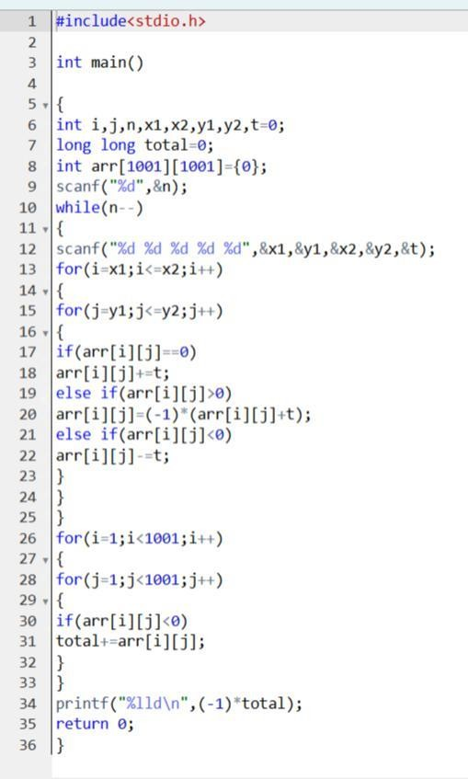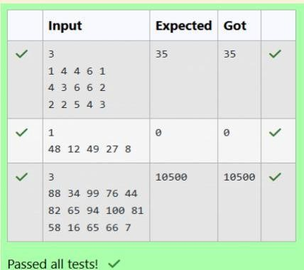

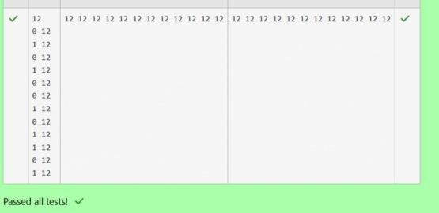Microsoft has come to hire interns from your college. N students got shortlisted out of which few were males and a few Females. All the students have been assigned talent levels. Smaller the talent level, lesser is your chance to be selected. Microsoft wants to create the result list where it wants the candidates sorted according to their talent levels,

but thereIs a catch. This time Microsoft wants to hire female candidates first and then male candidates.The task is to create a list where first all-female candidates are sorted in a

descending order and then male candidates Are sorted in a descending order. Input Format

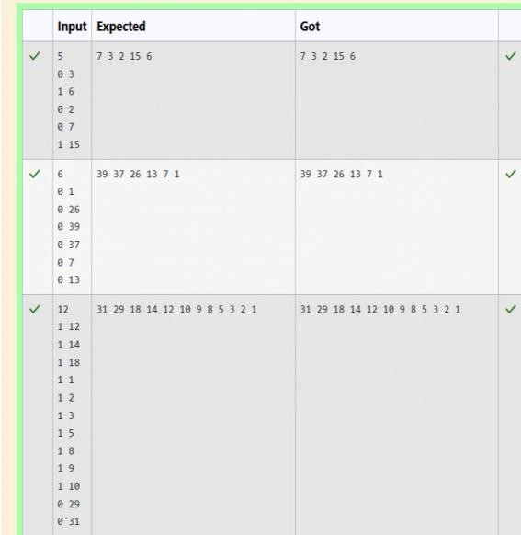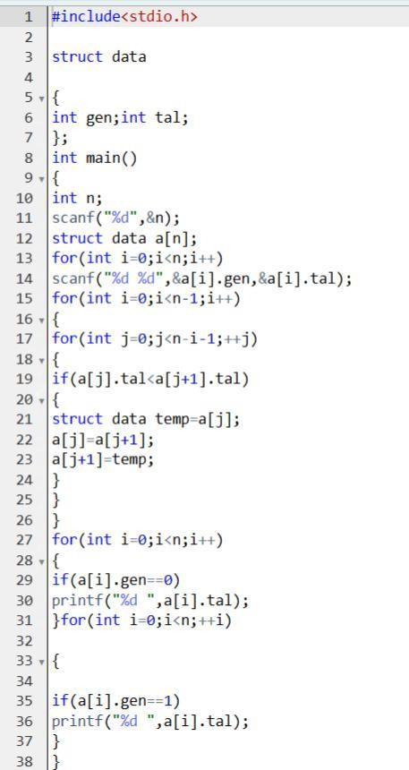The first line contains an integer N denoting the number of students. Next, N lines contain two space-separated Integers, ai and bi.The first integer, ai will be either 1(for a male candidate) or 0(for female candidate)The second integer, bi will be the candidate’s talent level.